**Progress report**

**Task 1**

Unfortunately, I did not manage to solve the first task completely because of several problems. The first and main problem is that access to the site for automatic use is protected by captcha, as well as access to the site is only with a vpn or proxy server. It took me long enough to understand (this is entirely my fault) about the existence of the captcha as I used a requests library, which returns to me not the correct html code, until I decided to use the selenium library, which engages web driver. When I found the existence of captcha I tried (with selenium) to bypass it manually, but it failed (as shown on the screenshot below)

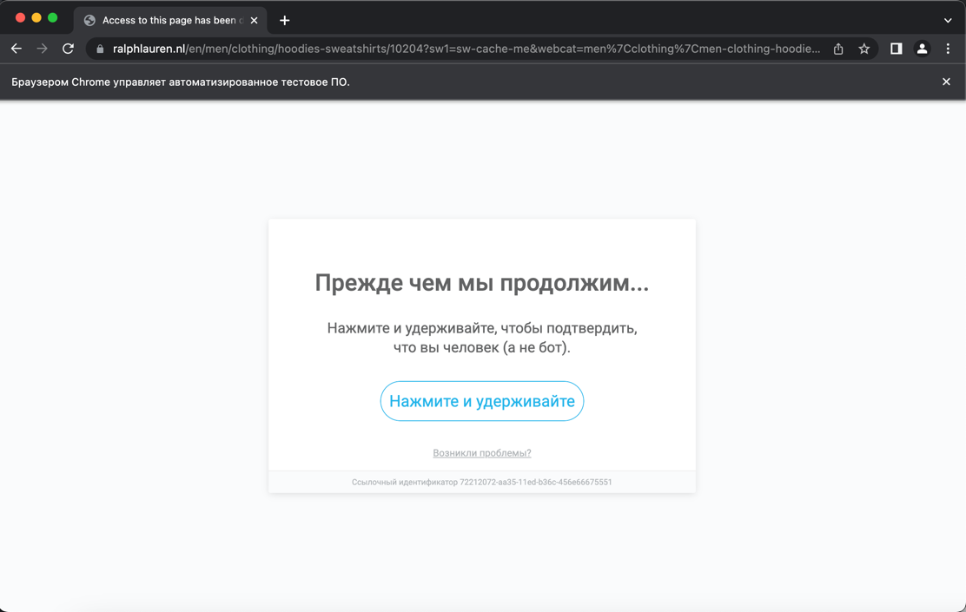

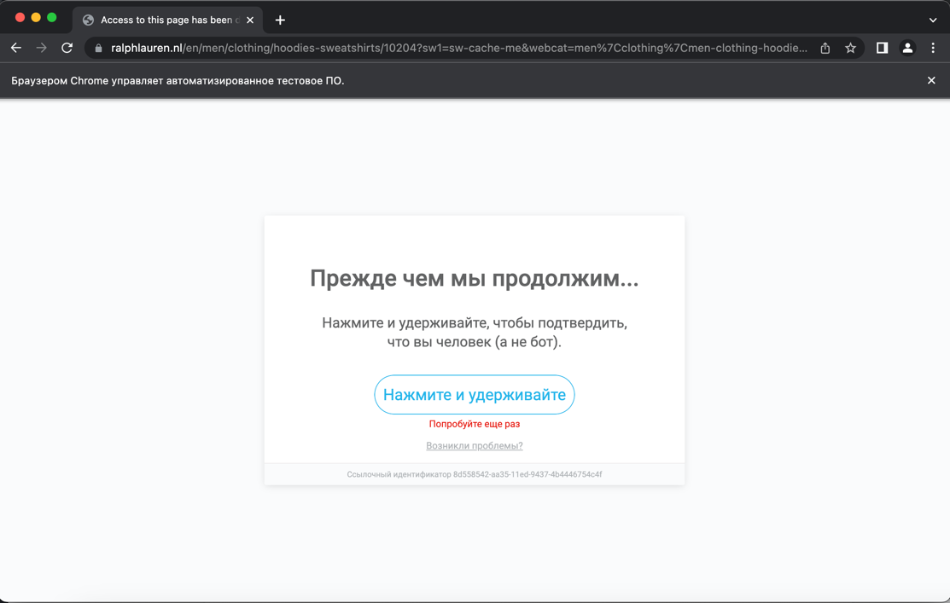

Bypassing captcha I still managed, I changed my VPN after each request and then the captcha disappeared, but if I used the same VPN twice, I was immediately blocked. The last problem was that the show more button didn't click (I never figured out why it happened, and it didn't matter). So, all I managed to do was to find the correlation between the links to the different clothing pages and, instead of automatically clicking the show more button, changed the links manually, but the problem was that I couldn't send two requests in a row, so I decided to load all the pages one by one manually. Then from those pages I scraped all the links to all the clothes and pictures, from the main page (as a bonus). Then the algorithm is simple, I had to go to each link and get the link to the images (with and without a person), but I could not do this because still I could not send more than one request non-manually (because of the captcha). The functions for loading html pages, loading links from them, and loading images from the main page are presented in the task1.py file.

**Task 2**

For the second task, I cropped the original photo using a mask and the bitwise_and function. Then I created a picture with a blue background, with the size of the original picture and superimposed the original picture on the background. The function is in the file task2.py. You can see the result in the picture below. The picture is blurry because of low resolution.

